CSA4723 – DEEP LEARNING FOR DISASTER MANAGEMENT
V.Sree Ruthin Reddy
192324112

11. Performance evaluation of Logistic regression Classifier using Breast cancer or Iris database
Aim: Performance evaluation of Logistic regression Classifier using Breast cancer or Iris database.
Algorithm:
- Import the required libraries.
- Load the Breast Cancer (or Iris) dataset from sklearn.datasets.
- Split the dataset into training and testing sets.
- Standardize the feature values using StandardScaler.
- Train a Logistic Regression model on the training data.
- Predict the labels for the test set.
- Evaluate the model performance using:
  - Accuracy Score
  - Confusion Matrix
  - Classification Report
- Display the results.
Code:
from sklearn.datasets import load_breast_cancer
from sklearn.model_selection import train_test_split
from sklearn.preprocessing import StandardScaler
from sklearn.linear_model import LogisticRegression
from sklearn.metrics import accuracy_score, confusion_matrix, classification_report

data = load_breast_cancer()
X = data.data
y = data.target

…
print("Accuracy:", accuracy_score(y_test, y_pred))
print("Confusion Matrix:\n", confusion_matrix(y_test, y_pred))
print("Classification Report:\n", classification_report(y_test, y_pred))
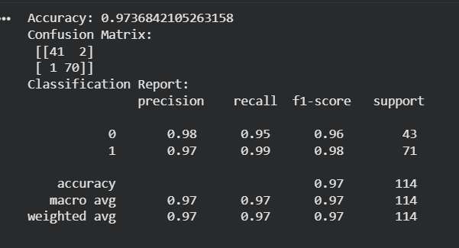
12. Performance evaluation of Random Forest Classifier using Breast cancer or Iris database.
Aim: To evaluate the performance of a Random Forest Classifier using the Breast Cancer or Iris dataset and analyze its accuracy, confusion matrix, and classification report.
Algorithm :
- Import the necessary libraries.
- Load the Breast Cancer (or Iris) dataset from sklearn.datasets.
- Split the dataset into training and testing sets.
- Train a Random Forest Classifier on the training data.
- Predict the output for the test data.
- Evaluate performance using:
  - Accuracy Score
  - Confusion Matrix
  - Classification Report
- Display the results.
Code:
from sklearn.datasets import load_breast_cancer
from sklearn.model_selection import train_test_split
from sklearn.ensemble import RandomForestClassifier
from sklearn.metrics import accuracy_score, confusion_matrix, classification_report

data = load_breast_cancer()
X = data.data
y = data.target

X_train, X_test, y_train, y_test = train_test_split(X, y, test_size=0.2, random_state=42)

model = RandomForestClassifier(n_estimators=100, random_state=42)
model.fit(X_train, y_train)

y_pred = model.predict(X_test)

print("Accuracy:", accuracy_score(y_test, y_pred))
print("Confusion Matrix:\n", confusion_matrix(y_test, y_pred))
print("Classification Report:\n", classification_report(y_test, y_pred))
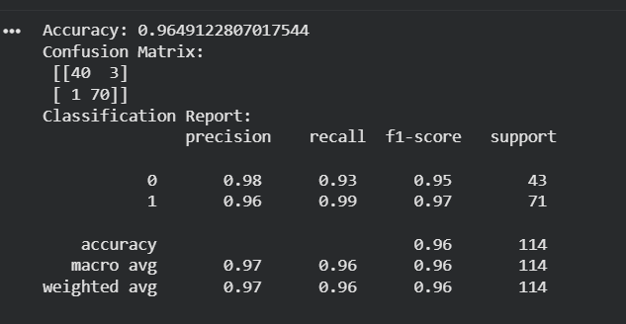
13. Performance evaluation of Decision Tree Classifier using Breast cancer or Iris database
Aim: To evaluate the performance of a Decision Tree Classifier using the Breast Cancer or Iris dataset and analyze its accuracy, confusion matrix, and classification metrics.
Algorithm:
- Import Libraries
Import the required libraries such as sklearn.datasets, DecisionTreeClassifier, and metrics.
- Load Dataset
Load the Breast Cancer or Iris dataset from sklearn.datasets.
- Split the Data
Divide the dataset into training and testing sets using train_test_split().
- Train the Model
Initialize a Decision Tree Classifier and train it using the training data.
- Make Predictions
Use the trained model to predict the target values for the test set.
- Evaluate Performance
Calculate the following metrics:
  - Accuracy Score
  - Confusion Matrix
  - Classification Report
- Display Results
Print all the evaluation metrics for analysis.
Code:
from sklearn.datasets import load_breast_cancer
from sklearn.model_selection import train_test_split
from sklearn.tree import DecisionTreeClassifier
from sklearn.metrics import accuracy_score, confusion_matrix, classification_report

data = load_breast_cancer()
X = data.data
y = data.target

X_train, X_test, y_train, y_test = train_test_split(X, y, test_size=0.2, random_state=42)

model = DecisionTreeClassifier(random_state=42)
model.fit(X_train, y_train)

y_pred = model.predict(X_test)

print("Accuracy:", accuracy_score(y_test, y_pred))
print("Confusion Matrix:\n", confusion_matrix(y_test, y_pred))
print("Classification Report:\n", classification_report(y_test, y_pred))
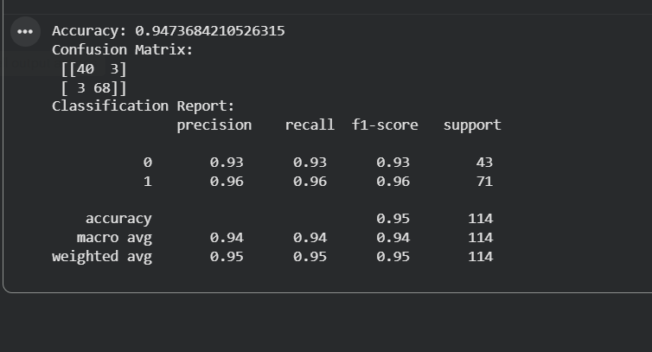
14. Performance evaluation of K-Nearest Neighbor Classifier using Breast cancer or Iris database.
Aim: To evaluate the performance of a K-Nearest Neighbor (KNN) Classifier using the Breast Cancer or Iris dataset and analyze its accuracy, confusion matrix, and classification metrics.
Algorithm:
- Import the necessary libraries (sklearn.datasets, KNeighborsClassifier, etc.).
- Load the Breast Cancer or Iris dataset from sklearn.datasets.
- Split the dataset into training and testing sets.
- Standardize the data using StandardScaler to improve KNN performance.
- Initialize the KNeighborsClassifier with a chosen number of neighbors (e.g., n_neighbors=5).
- Train the model on the training data.
- Predict the test data.
- Evaluate performance using:
  - Accuracy Score
  - Confusion Matrix
  - Classification Report
Code:
from sklearn.datasets import load_breast_cancer
from sklearn.model_selection import train_test_split
from sklearn.preprocessing import StandardScaler
from sklearn.neighbors import KNeighborsClassifier
from sklearn.metrics import accuracy_score, confusion_matrix, classification_report

data = load_breast_cancer()
X = data.data
y = data.target

X_train, X_test, y_train, y_test = train_test_split(X, y, test_size=0.2, random_state=42)

scaler = StandardScaler()
X_train = scaler.fit_transform(X_train)
X_test = scaler.transform(X_test)

model = KNeighborsClassifier(n_neighbors=5)
model.fit(X_train, y_train)

y_pred = model.predict(X_test)

print("Accuracy:", accuracy_score(y_test, y_pred))
print("Confusion Matrix:\n", confusion_matrix(y_test, y_pred))
print("Classification Report:\n", classification_report(y_test, y_pred))
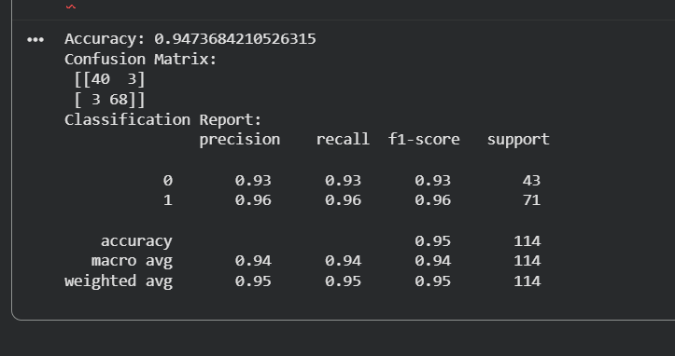
15. Performance evaluation of Support Vector Machine Classifier using Breast cancer or Iris database
Aim: To evaluate the performance of a Support Vector Machine (SVM) Classifier using the Breast Cancer or Iris dataset, and analyze its accuracy, confusion matrix, and classification metrics.
Algorithm:

- Import Required Libraries
Import sklearn.datasets, SVC, train_test_split, and evaluation metrics.
- Load Dataset
Load the Breast Cancer or Iris dataset from sklearn.datasets.
- Split the Data
Divide the dataset into training and testing sets using train_test_split().
- Normalize the Data
Use StandardScaler to standardize the feature values.
- Train the Model
Initialize and train an SVM Classifier (e.g., with kernel='linear' or 'rbf').
- Make Predictions
Predict the target labels for the test data.
- Evaluate Performance
Compute:
  - Accuracy Score
  - Confusion Matrix
  - Classification Report
- Display Results
Print all the evaluation metrics for performance analysis.
Code:
from sklearn.datasets import load_breast_cancer
from sklearn.model_selection import train_test_split
from sklearn.preprocessing import StandardScaler
from sklearn.svm import SVC
from sklearn.metrics import accuracy_score, confusion_matrix, classification_report

data = load_breast_cancer()
X = data.data
y = data.target

X_train, X_test, y_train, y_test = train_test_split(X, y, test_size=0.2, random_state=42)

scaler = StandardScaler()
X_train = scaler.fit_transform(X_train)
X_test = scaler.transform(X_test)

model = SVC(kernel='rbf', random_state=42)
model.fit(X_train, y_train)

y_pred = model.predict(X_test)

print("Accuracy:", accuracy_score(y_test, y_pred))
print("Confusion Matrix:\n", confusion_matrix(y_test, y_pred))
print("Classification Report:\n", classification_report(y_test, y_pred))
